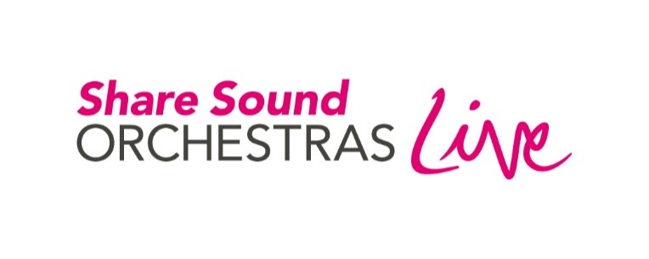

**Grand Finale**

**Wednesday 7 July 2021 – Programme**

Tonight’s production is the fruition of over twelve months of creative activity with young people from Cumbria, County Durham, Lincolnshire, Nottinghamshire, Norfolk and Suffolk. Share Sound was conceived by Orchestras Live as a unifying, inclusive creative force for good in response to the Covid-19 pandemic which prevented young people from playing music live together. Working with Music Education Hub partners, Orchestras Live has brought together some of the country’s finest musicians, composers, orchestras and digital producers to give young people a creative voice, to compose and perform together virtually. The culmination of this process is what you will experience tonight.

Thanks to all the young people that have taken part, the musicians, leaders, orchestras, tutors, managers, the technical team, parents and the entire OL team for the mammoth task of producing Share Sound.

Please do join in tonight through the livestream comments. Enjoy the show.

Sarah Derbyshire

Chief Executive, Orchestras Live

**Fanfare**

**Introduction with James Redwood, Artistic Director**

**First Light**

Lincolnshire Virtual Youth Orchestra and Chineke! Orchestra

**Found in Darkness**

Cumbria Share Sound Ensemble and the Royal Philharmonic Orchestra

**Tributaries**

Nottinghamshire Share Sound Young Musicians and Chineke! Orchestra

**Calling Out to You**

Suffolk Share Sound Ensemble and the Orchestra of the Age of Enlightenment

**Phoenix Rising**

Norfolk Share Sound Ensemble and the Royal Philharmonic Orchestra

**Forged by Fire**

Durham Music Virtual Orchestra and the Orchestra of the Age of Enlightenment

**James Redwood and Yshani Perinpanayagam in conversation**

**Fantasia**

Share Sound Orchestras and Music Hubs

# About the Music

## **Fanfare – from Fantasia by James Redwood**

Using musical ideas from across Share Sound, tonight’s programme begins with a 12 chord Fanfare and introduces the professional musicians who have been part of the Share Sound journey.

## **First Light – Lincolnshire Virtual Youth Orchestra**

This piece has been created by the largest single ensemble. Members of this 100-strong orchestra worked with music leader Rosie Bergonzi and some incredible musicians from Chineke! Orchestra, Europe’s first majority-Black and ethnically diverse orchestra. Taking initial inspiration from the music of Samuel Coleridge Taylor, musical ideas were generated to create a cinematic feast.

*“We created our piece by meeting up on Zoom and coming up with ideas based on a simple riff. Our piece is special because you can hear all the different themes coming together and it just fits really really well. After months of practice Zoom calls and composition committee meetings, the vital light shone on our final piece as a beacon of hope and optimism through lockdown.”*

## **Found in Darkness – Cumbria Share Sound Ensemble**

The first workshop in Cumbria resulted in a wealth of musical ideas that the young musicians took time to explore, discuss and improvise around with the support of Associate Music Leader, Yshani Perinpanayagam. With musicians from the Royal Philharmonic Orchestra in the studio, the ensemble was able to hear their musical ideas coming together in real time as James pieced the composition together.

*“It’s about coming together out of a difficult time and it’s a combination of cinematic orchestral music and rock. The way the song gradually builds up reflects on what it feels like to go from being really down and not sure about things when something different happens to gradually finding yourself and making a bit of progress to where you want to be and finding a way out of it”.*

## **Tributaries – Nottinghamshire Share Sound Young Musicians**

James Redwood co-led this project with James B Wilson, a composer with a special relationship with Chineke! Orchestra. James Wilson’s orchestral piece *Free-man*, a musical tribute to Dr Paul Stephenson honouring his part in the Bristol Bus Boycott of 1963, provided the creative starting point for the composition of *Tributaries*. The young people were asked to think about someone *they* would like to honour through music. Their heart-felt responses were translated into music and recorded by a team from Chineke! Orchestra, Inspire Music and the young musicians.

*“One of the main themes we were given was honoring people or paying tribute to people so a lot of people, when they composed their musical ideas, thought of celebrities or family members or just heroes that inspire them, and that’s why our piece is called Tributaries.”*

## **Calling Out to You – Suffolk Share Sound Ensemble**

Our Share Sound Associate Music Leader for Suffolk, Joe Qiu, chose a piece of repertoire close to the heart of the Orchestra of the Age of Enlightenment, a movement from the *Concerto a due cori* by Handel, as a starting point for the creative process. Joe and James took Handel’s bass line and turned it into the chorus of a song. In response to this chorus, young musicians at three schools created one new section each, which James arranged for a group of OAE players and an OAE Young Artist to perform alongside the young singers and percussionists.

*“We learned the chorus and then composed our own verse. It was very engaging and creative and it helped to bond a lot of people together with their musical abilities. I liked the workshop because it’s really musical and I love singing and playing the piano. I think it’s a really good way of bringing everyone together.”*

## **Phoenix Rising – Norfolk Share Sound Ensemble**

The Norfolk Share Sound Ensemble brought together an exciting mix of traditional orchestral instruments, electric guitars and baritone sax. The dramatic piece created by these young musicians divides the story of the life-cycle of a phoenix into three sections: Fire, Desolation, and Rebirth. The creative process was supported by Associate Music Leader, Yshani Perinpanayagam, musicians from the Royal Philharmonic Orchestra and tutors from Norfolk Music Service.

*“We created the piece by improvising about the life of the phoenix. Everyone contributed. It was great to work with musicians across the county as well as the RPO. The process was made harder by lockdown, but we overcame these difficulties and shared more ideas than what would have been possible in real life, allowing the piece to become as varied and interesting as possible. It showed me that you can put many ideas together to make one piece.”*

*“It’s a musical retelling of the Phoenix myth, split into three main parts- consumed by fire, reduced to ashes and rebirth and new life. The piece carries a very personal message about the pandemic, the message that even after despair and desolation, there will always be hope and joy.”*

## **Forged by Fire – Durham Music Virtual Orchestra**

Taking initial inspiration from Florence Price’s Juba Dance, Durham musicians explored themes of dance, desolation and reconciliation, improvising to a Juba Jam created by Associate Music Leader Alice Phelps and musicians from the Orchestra of the Age of Enlightenment. The ideas settled into a musical narrative that the piece explores.

Our Hero begins *Forged by Fire* in desolation, brooding on memories of past campaigns. With glints and memories of hope, our lonely hero journeys on. Then sensing danger on the horizon, they are suddenly under attack. The combatants circle each other, engaging in a dance off and argument until they gradually resolve to dance together, ultimately reconciling in a triumphant homecoming.

*“Our piece is called Forged by Fire. We created it over a couple of months over Zoom, which was certainly an interesting experience and not like anything I’d ever done before. Our orchestra has fed in ideas, musical phrases and opinions to evolve our piece from a major pentatonic scale and a few words just thrown around to a 7 minute musical narrative. Forged by Fire is a very epic piece – like something from a film or TV show – we all hope you enjoy it!”*

## **Fantasia – James Redwood**

*Fantasia* starts with the same 12 chords we heard at the start of this concert and features over 60 incredible professional musicians whose hard work and dedication made this project possible. So after all of your hard work, young people of Share Sound, here is a musical gift from us to you to say thank you for coming on this journey with us!

# Production

Share Sound is produced by Orchestras Live in partnership with:  

Cumbria Music Hub    
Durham Music Service (lead partner of Durham and Darlington Music Education Hub)

Lincolnshire Music Service

Norfolk Music Hub

Inspire Music (Nottinghamshire Music Hub)

Suffolk Music Education Hub

Chineke! Foundation

Orchestra of the Age of Enlightenment

Royal Philharmonic Orchestra

Artistic Director James Redwood

Associate Music Leaders Rosie Bergonzi, Yshani Perinpanayagam,

Alice Phelps, Joe Qiu, James B Wilson

Digital Producer Will Roberts

Audio Producer Jack Ross

Fantasia Visual Producer Andrew Nesbitt

Finale Producer  James Dickson

British Sign Language Interpreter Tamsyn Hockaday

Executive Producers Orchestras Live

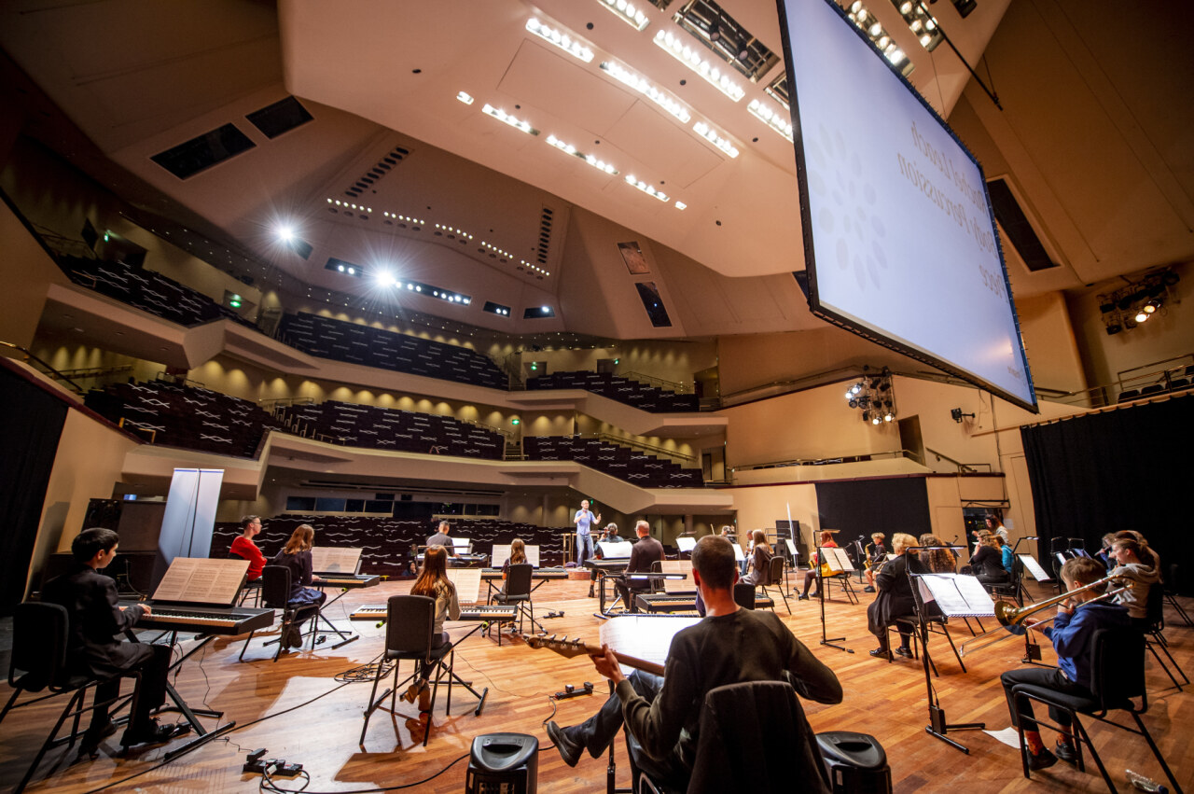

Share Sound Nottinghamshire musicians rehearse for their live performance with Chineke! Orchestra, led by Artistic Director James Redwood. Credit: Beth Walsh Photography

## **Cumbria Share Sound**

|  |  |  |  |  |
| --- | --- | --- | --- | --- |
| **Cumbria Share Sound Ensemble** | | | |  |
| Joseph Birkett  Morgan Beedell  Freya Bloomer  Hazel Burrow  Sam Burrows  Archie Campbell  Brodie Coulthard  Danny Collins  Taylor Dawson  Nat Dempsey  Hannah Elliott | Isla Gordon  Kane Harper  Katya Jackson  Jackson Jane  Ernestine Koo  Tiegan Lowthian  Rebecca Nicols  Isla Opie  El Parker  Chloe Robinson | | | Isobel Sinar  Amber Smith  Annie Spencer  Christopher Stephenson  Sam Stevenson  Matt Warwick  Elizabeth Watson  Sam Watson  Hannah Weakley  Noah Whitehead |
|  | | |  | |
| **Cumbria Music Hub/Youth Orchestra** | | | **Cockermouth School** **and Music Centre** | |
| Saxophone Justin Kent | | | Organ Martin Ulyatt | |
| Trumpet Andrew Tugwell | | | **Soundwave** | |
| Violin Sarah Kekus  Vocals Charlotte Jackson | | | Vocals Emma Dockeray  Director David Roberts | |
|  | | |  | |
| **Royal Philharmonic Orchestra** | | |  | |
| Associate Music Leader / Piano | | Yshani Perinpanayagam | | |
| Bassoon | | Helen Storey | | |
| Trumpet | | Toby Street | | |
| Violin | | David O’Leary | | |
| Double Bass | | Ben Wolstenholme | | |
|  | |  | | |
| **Production** | |  | | |
| Audio Production | | David Roberts, Soundwave | | |
| Visual Production | | Calvin Thornborrow, Soundwave | | |
| Photography | | Cumbria Young Musicians | | |
|  | |  | | |
| Producers | | Sarah Kekus, Cumbria Music Hub | | |
|  | | Martha Earley, Royal Philharmonic Orchestra | | |
|  | | Becky West, Orchestras Live | | |

## **Durham Share Sound**

|  |  |  |  |  |
| --- | --- | --- | --- | --- |
| **Durham Music Virtual Orchestra** | | |  |  |
| Emma Beckett  Leo Bruce  Ben Clark  Zoë Clark  Isobel Coulls  Jacob Dunn  Lilli Eerola  Naomi Grace Erlebach  Seilini Fernando  Senomi Fernando  Henry Geng  Raymond Geng  Hayden Gilliland  Dylan Glenton  Andrew Howe | | Holly Hughes  Lizzie Hughes  Lana Hunter  Luka Hunter  Robert Hunt  Lydia Iley  Peter Jones  Jessica Mckenzie  Kirsty McLachlan  Isabelle Mortimer  Rebecca Mortimer  Hannah Perry  James Plyming  Sam Plyming | | John Phillips  Helena Ritson  William Rolt  Eve Sims-Williams  Hannah Smith  Joe Sollis  Alan Swinney  Ty Thomas  Ebonie Totty  Zhenya Tumarkin  Lina van Hunen  Annabel Wade  Kara Warburton  Charlotte Winship |
|  | |  | |  |
| **Primary School Ensembles** | | | |  |
| Brass | Easington Colliery Primary School | | | |
| Strings | Our Lady and St Thomas RC Primary School, Willington | | | |
| Strings | St George’s Church of England Academy | | | |
| Ukuleles | Byers Green Primary School | | | |
|  |  | | | |
| **Durham Music Service** |  | | | |
| Youth Orchestra Leads | Tamsin Diment, Christopher Hartley | | | |
| Youth Orchestra Staff | Zoe Hodgson, Andrew Jakob, Greg Pullen, Chris Senior | | | |
| Primary School Leads | Kathryn Coulls, Katie Hibbard, Anna Millar, Christina Mortimer | | | |
|  |  | | |  |
| **Orchestra of the Age of Enlightenment** | | | | |
| Associate Music Leader /  Double Bass | Alice Phelps | | |  |
| Bassoon | Joe Qiu | | |  |
| Cor Anglais | Cherry Forbes | | |  |
| Trumpet | Adrian Woodward | | |  |
| Percussion | Will Edwards | | |  |
| Violin | Henrietta Wayne | | |  |
| Double Bass | Carina Cosgrave | | |  |
|  |  | | |  |
| **Production** |  | | |  |
| Audio & Visual Production | Fred Hollingsworth, North East Audio | | | |
|  |  | | |  |
| Producers | Carolyn Norris, Durham Music Service | | | |
|  | Cherry Forbes, Orchestra of the Age of Enlightenment | | | |
|  | Becky West, Orchestras Live | | | |

## **Lincolnshire Share Sound**

|  |  |  |
| --- | --- | --- |
| **Lincolnshire Virtual Youth Orchestra** | |  |
| Hana Ahmed-Mahmoud  Emily Barker  Sophie Barley  Elizabeth Betts  Daniel Bradbury  Holly Bradbury  Ben Brophy  Fiona Brown  Megan Brown  Olivia Brown  Emily Brunt  Josie Buchler  Fearne Carpenter  Lucy Carter  Jack Church  Samuel Davie  Jaden DeWeese  James Diamond  Miriam Dodd  James Eames  Alice Edgar  Artemis Eng  Athena Eng  Aurora Fantasia  Patrick Fox  Holly French  Jessica Gates  Elizabeth Gibson  Isobelle Gibson  Harry Gilbert  William Gray  Gus Hagger  George Hall  Sophie Henderson  Sophie Hewerdine  Eleanor Hewitt | Emily Hill  Jacob Hill  Pawel Hoffmann  Méabh Hogan  Amelia Jack  Caitlin Jackson  Lauren Jackson  Aakash Jansari  Shivani Jansari  Eleanor Langman  George L'Estrange  Thomas L'Estrange  Matthew Lewis  Thomas Li  Oscar Lond  Elizabeth Love  Sophia Love  Clara Lytle  Connie Malkinson  Lauren Mannering  Honey Marcus  Oliver Marsh  Isabelle Martin  Lily Martin  Heather Mayer  Charlie Merricks  Leah Moses  Louise Muxworthy  Pawel Nieweglowski  Abraham Olalere  Lidia Olayo  Aidan Parker  Leo Pool  Kellan Poole  Oscar Potts | Thomas Preston  Emma Rock  Hannah Rogers  Noah Rogers  Eliza Rudd  Florence Rudd  Sarah Ruddock  Florence Ryan  Matthew Simmons  Amber Smith  Evelyn Spencer  Sophia Spencer  Sachithasingam Suresh  Thuraisingam Suresh Singam  Ola Turner  Madeleine Walton  Sijin Wang  James Wardell  Rachel Weston  Jack Wheatley  Joshua Wheldon  Alex Whitaker  Amelia Whitfield  Freya Whitfield  Heather Wilde  Alex Williams  Marcus Williams  Niamh Williams  Hollie Wilson  Jack-Stanley Winder  Katie Winfield  Emily Wood  Will Wood  Ed Wynn  Gilbert Wynn |
|  |  |  |
| **Lincolnshire Music Service** | |  |
| Sarah Bongiovanni  Hannah Bourne  Rebecca Brown  Vicky Carter  David Chambers  Sarah Chambers  Malcolm Duckels | Alex Greenfield  Rachel Hill  Joanne Lidgett  Gayle Lond  Asha Matthan-Rogers  Thea Maund | Andrew Raine  Jon Richmond  Janice Stockdale  Martin Stockdale  Jack Swift  Ann Wright |
|  |  |  |
| **Chineke! Orchestra** |  |  |
| Associate Music Leader / Handpan | Rosie Bergonzi |  |
| Clarinet | Anton Butler- Clarke |  |
| Trumpet | Gabriel Dias |  |
| Violin | Fra Rustamji |  |
| Cello | Zara Hudson-Kozdoj |  |
|  |  |  |
| **Production** |  |  |
| Audio and Video Production | Faded Productions | David Chambers, Jenny Chambers |
|  | Dawn Production House | Tom Chambers |
| Photographer | First Light John Burn |  |
|  |  |  |
| Administrative Support | Sarah Burns, Rosie Lowe | |
|  |
| Producers | Jennifer McKie, Lincolnshire Music Service | |
|  | Malcolm Duckels, Lincolnshire Music Service | |
|  | Ishani O'Connor, Chineke! Foundation | |
|  | Jan Ford, Orchestras Live | |

## **Norfolk Share Sound**

|  |  |  |
| --- | --- | --- |
| **Norfolk Share Sound Ensemble** | |  |
| Emily Bradfield  Archie Brett  Anna Crosby  Tom Dawe  Reuben Dorling-Winterbourne  Billy Harrold  Fiona Hill  Christian Holyoake | Dylan Irvine  William Johnson  Felonica Kirkham  Emily Knights  Thomas Lucchini  Adelaide Mason  Tristan McCardel | George Medhurst  Jasper Pike  Joshua Richmond  Callum Salton  William Savage  Jimmy Thomson  Finty Woolf |
|  |  |  |
| **Norfolk Music Hub** |  |  |
| Bassoon | Sylvia Newton |  |
| Saxophone | Dave Taylor |  |
| Trumpet | Dan Mothers |  |
| Cello | Ingrid Perrin, Helen Stowell | |
| Guitar | Alistair Bell |  |
|  |  |  |
| **Royal Philharmonic Orchestra** | |  |
| Associate Music Leader | Yshani Perinpanayagam |  |
| Flute | Joanna Marsh |  |
| Trombone | Rupert Whitehead |  |
| Violin | Sophie Mather |  |
| Vocals | Natalie Williams |  |
|  |  |  |
| **Production** |  |  |
| Audio Production | Dave Taylor |  |
| Video Production | Alison Bell, Tim Brain, Josh Ingamells | |
|  |  |  |
| Producers | Krista Ribbons, Norfolk Music Hub | |
|  | Martha Earley, Royal Philharmonic Orchestra | |
|  | Stuart Bruce, Orchestras Live | |

## **Nottinghamshire Share Sound**

|  |  |  |
| --- | --- | --- |
| **Nottinghamshire Share Sound Ensemble** | |  |
| Rosa Armstrong  Jacob Bishop  Amy Bradley  Evelyn Byfield  Tallulah Iris Cartwright  Bailey Charlesworth | Suzanne Clack  Chloe Coulson  Maria Dunning  Sylvie Dunning  Bethan Harris  Riley Nandal-White | Joseph Pryce  Sophie Waite  Evie-Mae Whitehead  Freddy Whitehead |
|  |  |  |
| **Inspire: Culture, Learning and Libraries / Nottinghamshire Music Hub** | | |
| Flute | Alicia Fletcher |  |
| Flute / Piano | Lucy Reid |  |
| French Horn | Calogera DiMiceli |  |
| Bass | Alan Ramsay |  |
| Workshop Practitioners | Joel Hall, Roger Jepson, Rupert Trippett, Saree Wilson | |
|  |  |  |
| **Chineke! Orchestra** |  |  |
| Associate Music Leader | James B Wilson |  |
| Clarinet | Anton Butler-Clarke |  |
| Cello | Zara Hudson-Kozdoj |  |
| Violin | Fra Rustumji |  |
|  |  |  |
| **Production** |  |  |
| Audio and Visual Production | Alan Ramsay, Inspire: Culture, Learning and Libraries | |
| Live Performance Film | Neil Pledger, Inspire: Culture, Learning and Libraries | |
| Videos | Nottinghamshire Share Sound Young Musicians | |
|  |  |  |
| Project Administrator | Lu Blackband, Inspire: Culture, Learning and Libraries | |
|  |  |  |
| Producers | Lucy Reid, Inspire: Culture, Learning and Libraries | |
|  | Ishani O’Connor, Chineke! Foundation | |
|  | Stuart Bruce, Orchestras Live | |

## **Suffolk Share Sound**

|  |  |  |  |  |
| --- | --- | --- | --- | --- |
| **Suffolk Share Sound Ensemble** | | |  | |
| **Thomas Wolsey Ormiston Academy** | | **Northgate High School** | | **Stone Lodge Academy** |
| Jacob  Kia  Lewis  Matt  Morgan  Paris  Ryan | | Anthony  Elliot  Justin  Keziah  Mostafa  Opal | | Alex  Ella  Jayden  Jayke  Jen  Jordan  Phoebe  Summer  Toby |
|  | |  | |  |
| *Teacher:*  Karen Ludlow | | *Teachers:*  Sarah Asher, Catherine Donker | | *Teacher:*  Wendy Matthews |
|  |  | |  | |
| **Orchestra of the Age of Enlightenment** | | |  | |
| Associate Music Leader / Bassoon | Joe Qiu | |  | |
| Oboe | Nicola Barbagli | |  | |
| Oboe / Cor Anglais | Cherry Forbes | |  | |
| Violin | Alice Poppleton | |  | |
| Double bass | John Henry Baker | |  | |
| Percussion | Will Edwards | |  | |
| Voice and Keyboard | Grace Utting, OAE Young Artist | | | |
|  |  | |  | |
| **Production** |  | |  | |
| Audio Production | Jack Culpin, Jack Ross | | | |
| Video Production | Jack Culpin, Andrew Thomson | | | |
|  |  | |  | |
| Producers | Helen Simms, Suffolk Music Education Hub | | | |
|  | Cherry Forbes, Orchestra of the Age of Enlightenment | | | |
|  | Stuart Bruce, Orchestras Live | | | |

**Orchestras Live**

Orchestras Live believes orchestras are for everyone. We create environments where music and creativity can thrive. We work to ensure communities across the country have access to world-class orchestral experiences.

With over 50 years’ experience, we make orchestral music relevant to people’s lives through dynamic partnerships and innovative projects, particularly in culturally under-served areas of England. We champion audience development; inspire the young and rejuvenate the old, giving communities voice, and joining generations in award-winning projects.

Within the sector, we develop talent to increase quality, diversity and sustainability of music delivery and participation. We occupy the heart of the orchestral world, leading thought, learning new approaches, stimulating debate and driving change.

Orchestras Live is a national charity and an Arts Council England portfolio organisation.

<https://www.orchestraslive.org.uk/>

**Thanks to our partners and funders**

Share Sound is a national project supported by Arts Council England, The Weston Culture Fund (Garfield Weston Foundation), The Harold Hyam Wingate Foundation and The Radcliffe Trust.

Share Sound Durham is additionally supported by the Scops Arts Trust and the Foyle Foundation.

The Harold Hyam Wingate Foundation

