New Connections Evaluation Report

Executive Summary

The Project
New Connections was a Knowledge Exchange project designed and delivered in partnership by Orchestras Live and Leeds Conservatoire in spring-summer 2023, as part of a three-year partnership. It was designed to explore how, through partnership and co-design, the Conservatoire can engage with community groups and trial new ways of creating relevant orchestral experiences while supporting students to develop their creative leadership skills. Leeds Conservatoire students took part in a series of skills development workshops prior to delivery of the creative community projects with a professional artistic team.

New Connections succeeded in establishing new partnerships between Leeds Conservatoire and three community partners: Burley and Woodhead Primary School; Made with Music’s Sunshine and Smiles music group for young people with Down Syndrome and their families; and Meeting Point, a community support group for refugees and asylum seekers. The professional music leaders, Manchester Camerata and Leeds Conservatoire students worked with each community group to co-create brand new music to perform together with the orchestra at the final concert as part of a varied musical programme.

The project engaged an external evaluator, Kirsty Halliday, Red Sands Arts Management, to assess the effectiveness of the co-creative process for community groups and the skills development for students, with recommendations for how the partnership develops this work further. The full New Connections Evaluation Report is available to access here.
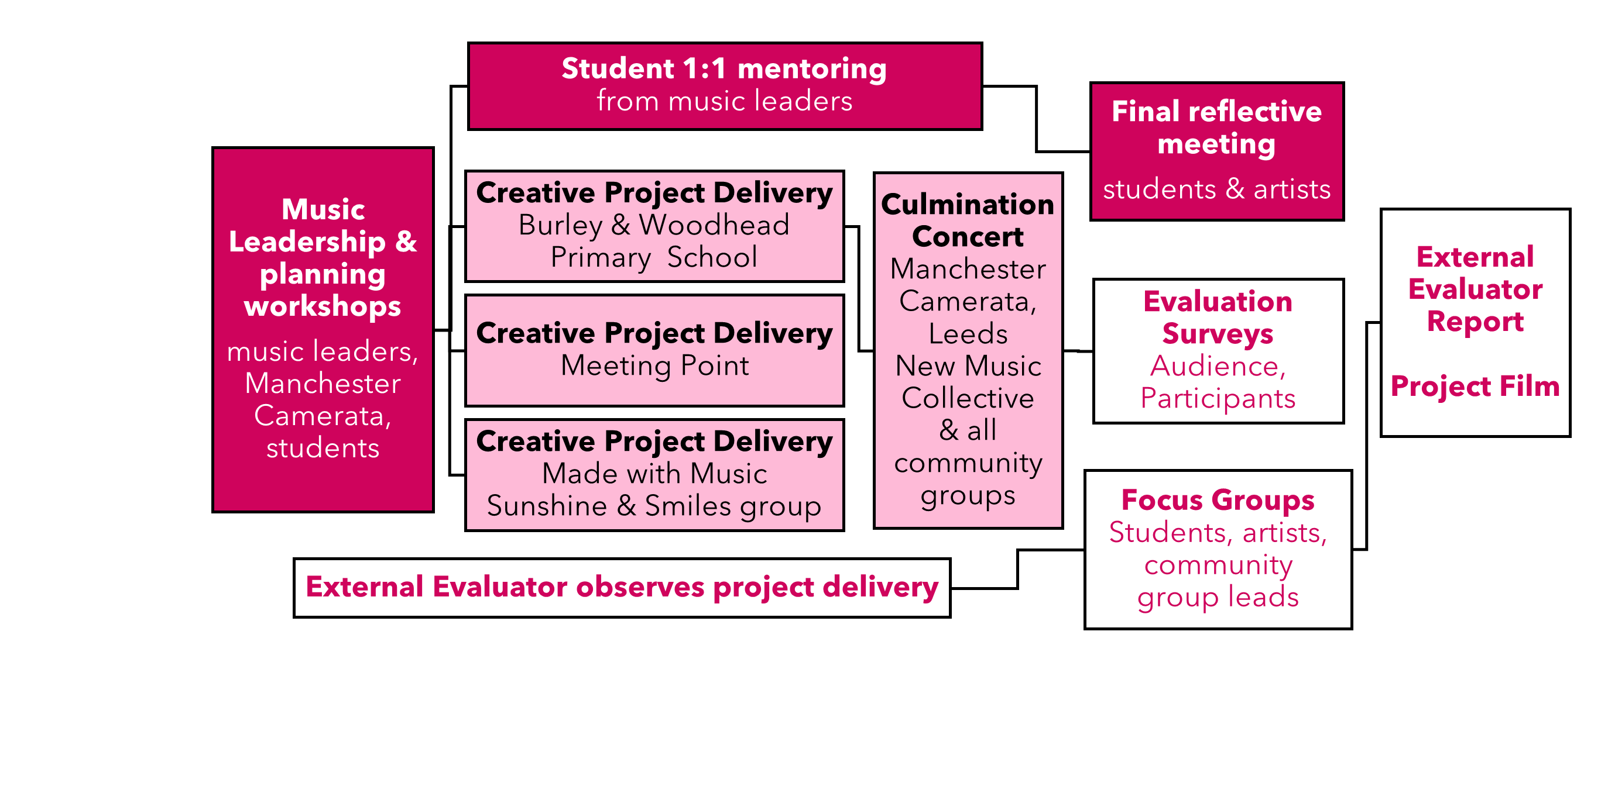

What happened:
15 community workshops | 5 skills workshops | 3 new pieces of co-created music | 1 culmination concert

Who we engaged with:
3 | 76 | 17 | 21 | 186
community partners | community participants | Leeds Conservatoire students | professional musicians | audience members

Talk about cultural capital – this is cultural capital on steroids!
Community group lead

Evaluation Surveys Summary
Feedback surveys demonstrated very positive outcomes for the community participants and audiences reached through the project. A full summary of the survey findings is available in section 3.3 of the Evaluation Report.
93% | of participant survey respondents rated their experience of the project as very good, 7% as good.

Wowwwwwww. What a fantastic concert. It's my first experience with such type. I'm very proud that exist such creative and big hearted people - musicians.
Audience member

It felt amazing that the orchestra had learnt our song and were playing it to accompany us. It gave us so much energy and made us feel electric.
Participant
It felt amazing that the orchestra had learnt our song and were playing it to
accompany us. It gave us so much energy and made us feel electric.
Participant

Participant

89% | of audience survey respondents had a good time, were proud of their community and felt the concert had a positive impact on their own wellbeing
This project really helped me feel a part of something big, thank you. It was so special to be part of it, to have my family there to see me doing something special. I have new friends and I have a wonderful experience, thank you.
Participant

88% | of participant survey respondents said that they did something they didn’t know they were capable of

I'm now a lot happier and believe I can do a lot more than I thought. Thank you.
Participant

89% | of participant survey respondents said the project made them feel more confident about doing new things

My child is living on cloud 9 and high as a kite….
You have fulfilled one of their dreams to be with an orchestra!! They've spent years watching them on their iPad! My dream too, to be beside all those amazing people and instruments too.
Participant

Findings and Recommendations
The project evaluation covered a wide range of outcomes from across the multi-layered project. Having clearly established the positive cultural value of creative community music projects, findings focus on the need to train and prepare the future musical workforce to understand and deliver this kind of work. The report’s recommendations set out the principles to support the development of creative music leadership skills and training within a Conservatoire environment.

Orchestral co-creation is an effective way to create cultural value with communities and delivers positive impacts for participants.

New Connections demonstrated a wide range of positive impacts for participants, providing an enriching experience, supporting personal skills development, social connection, confidence and wellbeing.

The orchestral culmination concert in a professional space, The Venue, significantly enhanced and deepened the positive impact for participants. The inclusive nature of the concert effectively created positive cultural value for those involved and the audience.

Everyone was very involved in the performance, the co-created music was brilliantly arranged and it was really joyful seeing some of the groups dancing along to the music we were playing, I thought that was a really good idea.
Leeds Conservatoire student

Recommendation:
Given the increased emphasis that professional music organisations are placing on access, inclusion and community engagement, it is vital that musicians develop knowledge and understanding of orchestral co-creation and its impact for participants, to effectively prepare them for their future career.

Commitment: Future iterations will support Leeds Conservatoire in delivering high quality, action learning community co-creation projects, raising the profile of this work within the curriculum and strengthening their relationship with their local community.

The key elements of effective co-creative musical practice

Section 3.5 of the Evaluation Report evidences these key areas for effective co-creative practice:

Relationship building in advance of projects with participant group leads and including them in workshop delivery and reflective discussion throughout a project is crucial to ensuring a high-quality, positive and successful community co-creative process. This will create the optimum environment for participants to work with professional musicians, where their voice is heard and valued and positive personal development for individuals can happen effectively.

Recommendation:
It is essential that music students develop a sound knowledge and understanding of best practice and effective delivery methods for co-creation that will enable them to work creatively with communities and maximise positive impacts for participants.

Commitment: Partners will use this framework for a skills development programme within Leeds Conservatoire’s curriculum for students to learn about best practice in music leadership.

The core skills required to deliver high quality community co-creation extend beyond students’ musical specialism. These non-musical skills will underpin their practice as an artist with a portfolio career.

Musical skills are one of seven skill areas that musicians require to deliver effective creative community music making (see Section 3.5.8 of the full Evaluation Report).

I loved the sessions! [skills development workshops]. I learnt a lot from the experience, a lot of which I will take forward with me in the future.
Leeds Conservatoire student

Recommendation:
To prepare musicians for a professional portfolio career, training must encompass this core non-musical skill set. This will support the ongoing effective development of an individual’s artistic practice as performer, composer, producer and educator.

Commitment: A holistic skills development programme within Leeds Conservatoire will give equal emphasis to the range of skills employers require of musicians, giving students confidence to understand, use and grow non-musical core skills and attributes to support their developing music leadership.

An understanding of reflective practice is a crucial skill musicians need in order to deepen their understanding of effective music leadership practice. This skill will also underpin the development of musicians’ own artistic practice throughout their career.

One-to-one mentoring for student musicians in an action learning project environment was a crucial part of their personal development. However, reflective practice and understanding their own skills development in music leadership was an area they found more challenging. The instructive model of instrumental learning in music education is very different to reflecting on your craft as a musician in a creative workshop setting and understanding that good leadership can take many forms and is often not about ‘delivering from the front'.

Recommendation:
Further research and testing is required to learn how to effectively train music students in reflective artistic practice in Higher Education institutions, a skill that will underpin their artistic practice throughout their career.

Commitment: The partners will use the next phase of the New Connections programme to test and refine a reflective practice framework, establishing a dedicated reflective practice workshop as part of the skills development programme.

The lack of academic research into musical co-creation and the social value of community collaboration is impacting the future-proofing of the musical workforce.

While a comprehensive literature review was beyond the scope of the evaluation, the review carried out indicates that there is a limited amount of published research on community co-creation and collaboration in a musical context, particularly in community co-creation with professional orchestral musicians.

Recommendation:
More extensive academic research should be undertaken into co-creative musical practice and music leadership to further explore the effectiveness of a range of delivery models. This will develop resources to deepen the sector’s understanding of the training musicians require to create cultural value with communities.

Commitment: Partners will seek opportunities to fund research in this area to establish an evidence base for the cultural and social value of a community co-creative approach within the music and Higher Education sectors.

…being introduced to the possibilities of collaborations between professional orchestras and community groups. […] Professional orchestral playing is not a career I’ve seen as ‘for me’ or considered as normally I find it more stressful then enjoyable. This concert has changed that for me as I can see myself playing in more orchestras that have a community focus.
Leeds Conservatoire student

New Connections is co-produced by Leeds Conservatoire and Orchestras Live.
Music leaders: James Redwood, Amina Hussain, Kathryn Sturman, Hannah Dilworth, Manchester Camerata
Leeds Conservatoire project and ensemble musicians
Burley and Woodhead C of E Primary School
Made with Music Sunshine and Smiles Group
Meeting Point Women’s Group
Evaluator: Kirsty Halliday, Red Sands Arts Management

